ETHERNET STANDERED AND SPECIFICIATION
- Draw a simple diagram showing the pin layout of an RJ-45 connector and label the color codes for the T568A and T568B Ethernet wiring standards.
Answer
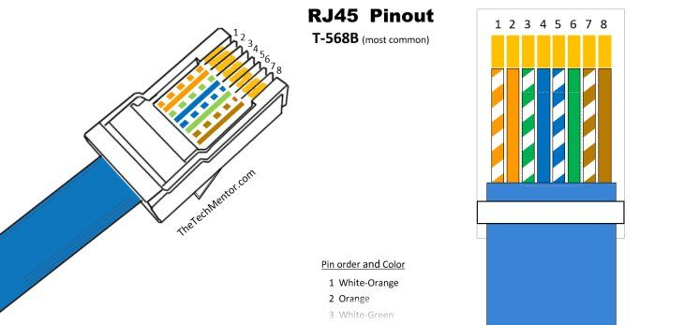

- Create a table comparing the key specifications of Ethernet standards 10BASE-T, 100BASE-TX, and 1000BASE-T, including speed, cable type, maximum cable length, and connector type.
Answer
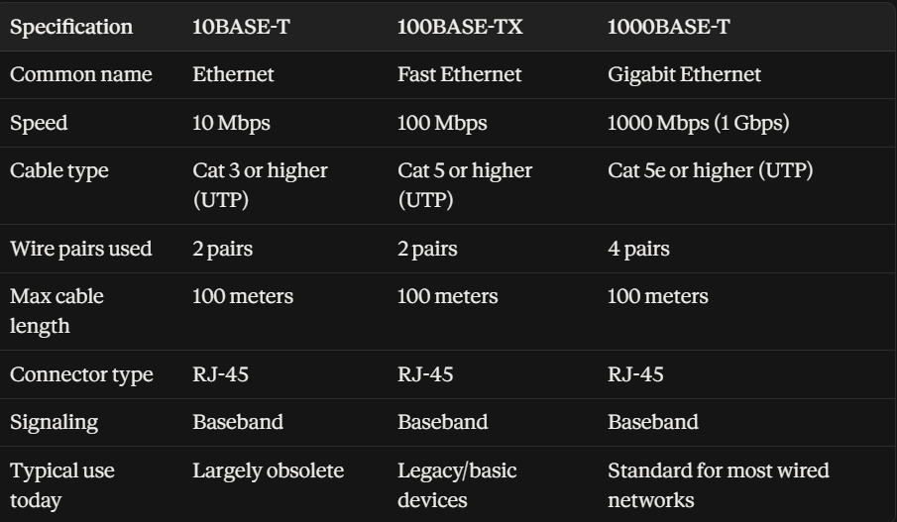
A few points worth calling out:
- Max cable length stays constant at 100m across all three standards — that's a fundamental limit of twisted-pair Ethernet over copper (signal degradation beyond that), not something that improves with speed.
- 1000BASE-T is the odd one out in cable usage — it uses all 4 wire pairs simultaneously (bidirectionally) to hit gigabit speeds, while 10BASE-T and 100BASE-TX only use 2 of the 4 pairs.
- For your gaming zone setup, Cat 5e or Cat 6 cabling running 1000BASE-T is the practical sweet spot — it's backward compatible with older 10/100 devices if needed, but gives you full gigabit speed for consoles and streaming.

- Given a scenario where you need to connect two laptops directly using Ethernet, explain which cable (straight-through or crossover) you would use and why. Think about how transmit and receive pairs are wired in each cable type.
Answer
For directly connecting two laptops via Ethernet, you'd traditionally use a crossover cable — though there's an important modern twist worth explaining.

Why a Crossover Cable Was Needed
Ethernet devices transmit data on one wire pair and receive on another. On a straight-through cable, pin 1 on one end connects to pin 1 on the other end, pin 2 to pin 2, and so on — the wiring is identical at both ends (e.g., T568B on both sides).
This works fine when connecting a laptop to a switch or router, because the switch's ports are internally wired to flip transmit and receive — the switch "listens" on the pins the laptop "talks" on, and vice versa.
But when you connect two laptops directly with a straight-through cable, both devices are transmitting on the same pins (1,2) and listening on the same pins (3,6). Laptop A's transmit signal arrives at Laptop A's own receive pins on the other end — never reaching Laptop B's receive circuitry. No communication happens.
A crossover cable solves this by physically wiring one end as T568A and the other end as T568B. This swaps the transmit pair (pins 1,2) with the receive pair (pins 3,6) between the two ends — so Laptop A's transmit pins connect directly to Laptop B's receive pins, and vice versa.

The Modern Twist: Auto-MDIX
Here's the practical reality for you today: most laptops made in the last ~15 years have Gigabit Ethernet ports with a feature called Auto-MDIX (Automatic Medium-Dependent Interface Crossover). This lets the network interface automatically detect whether it needs to "cross over" the signal and does it electronically — regardless of which cable type you plug in.
So in practice:
- If both laptops have Gigabit (1000BASE-T) ports → a straight-through cable will work fine, thanks to Auto-MDIX.
- If either laptop has an older 10/100 Mbps port without Auto-MDIX → you'll need a genuine crossover cable, or the connection won't establish.
Bottom line for the exam-style answer: the correct textbook answer is a crossover cable, because it's specifically designed to swap the transmit and receive pairs so two like devices (laptop-to-laptop, switch-to-switch) can communicate directly — which is the underlying networking principle being tested. Just be aware that in real-world modern hardware, Auto-MDIX often makes this workaround unnecessary.
- List three real-world devices in your home or college that use Ethernet connections, and for each, specify the likely Ethernet standard (e.g., 100BASE-TX, 1000BASE-T) they support.
Answer
Three common household and office/lab devices that use wired Ethernet connections, along with their supported standards:
- Desktop PC / Gaming Console (e.g., PlayStation 5)
  - Details: Modern motherboards and current-generation gaming consoles come equipped with Gigabit Ethernet (or faster, such as 2.5GBASE-T) to ensure low latency and high bandwidth for online gaming and large file downloads.
- Network-Attached Storage (NAS) / Micro-Server (e.g., Raspberry Pi 4)
  - Supported Standard: 1000BASE-T (Gigabit Ethernet)
  - Details: Home storage servers and modern single-board computers use 1000BASE-T to quickly move high-definition media, backups, and large datasets across a local network.
- Smart TV / Network Printer / VoIP Desk Phone
  - Supported Standard: 100BASE-TX (Fast Ethernet)
  - Details: Many Smart TVs and network office devices rely on 100 Mbps Fast Ethernet because streaming 4K video or sending print jobs rarely requires more than 25–50 Mbps. Manufacturers use 100BASE-TX to optimize hardware costs while comfortably meeting bandwidth needs.

